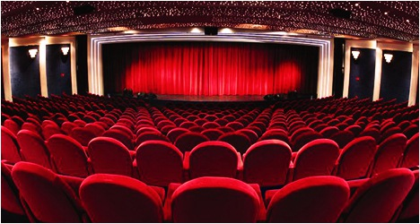

**WEB TECHNOLOGY AND STANDARDS:**

**FINAL PROJECT**

**MOVIE MANAGEMENT SYSTEMS**

**PROFESSOR: Yiling Lin**

**Submitted By:**

**CHERYL VALERIAN DSOUZA**

**REGINA SELVI PANNEER SELVAM**

**ROHIT PURSWANI**

Table Contents

Introduction 03

Abstract 03

Tools/Platform 04

Framework 05

References

**INTRODUCTION**

Movie Management System is an online website for the theater named Pittsburgh’s Own Movies located in Pittsburgh. This document specifies the framework of the project and also the platform used in this project.

**ABSTRACT**

This project contains a website for a theater named Pittsburgh’s Own Theater located at four locations (Southside, Greenfield, Bloomfield and South Oakland) within Pittsburgh. The theater aims at attracting Hindi Movie Lovers. This online website offers user the following features: to create an account, to view released movies and upcoming movies with their show timings, to book tickets, to review a movie and to view the reviews for a movie.

**Tools/Platforms**

* HTML
* JAVASCRIPT
* JSP
* Servlets
* JQUERY
* CSS
* DERBY DATABASE

1. **HTML**: Used to create the website layout for viewing the details online.
2. **JAVASCRIPT**: Used for the validation of the Login Page.
3. **JSP**: Used to present the data to the user .
4. **Servlets**: Used to handle input from the JSP form or specific URL written in the JSP page.
5. **JQUERY**: Used for the validation of the Sign up page.
6. **CSS**: Used to add the style and font to the website.

7.**Derby Database:** Used to create the database for the website which includes the tables below:

a. Customer Table: When a customer creates an account on the website for the first time all the details are saved in this table.

* Customer Name
* DOB
* Sex
* Phone Number
* Address
* City
* Zip Code
* Email

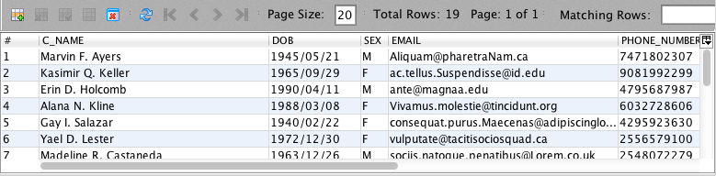

b. Login Customer: This table contains the following:

* User ID
* Password
* Phone Number

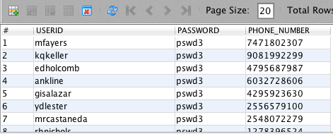

c. Movie Details: This table contains the following:

* Movie Name
* Time
* Price
* Location

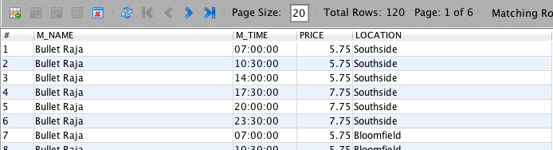

d. Give Review: This contains the review details for a movie when a user submits the review on the online website. The table contains the following:

* Movie Name
* Stars
* Review Description

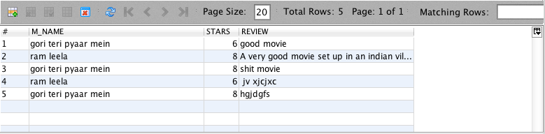

5.Booking Details: When a user books a movie ticket online the following data is saved in this table:

* Ticket ID (Auto Increment: This will be generated automatically for a customer when he/she books a movie ticket).
* Movie Name
* Phone number
* Location

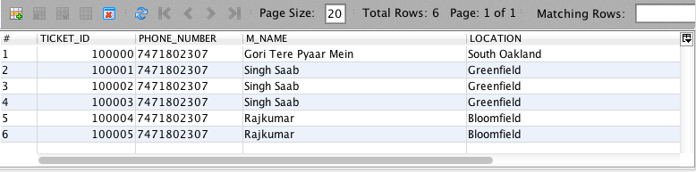

6. Movie: This contains data for the four different locations and the movie names that are being shown in these theaters.

* Movie Name
* Location
* Price

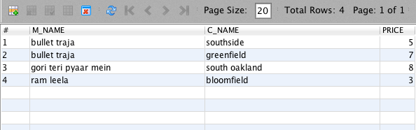

**Framework**

Online website contains the following pages:

1. **Home Page**: This page is the home page which holds an option for the user to log in or if the user is a new user then it holds an option to sign in. If the user logs in then he/she is directed to book ticket page where the user can view the show timings and book tickets as per his/her choice. The home page appears as below:

2**.Login Page**: There are two login options: One for the user and other for the Manager.

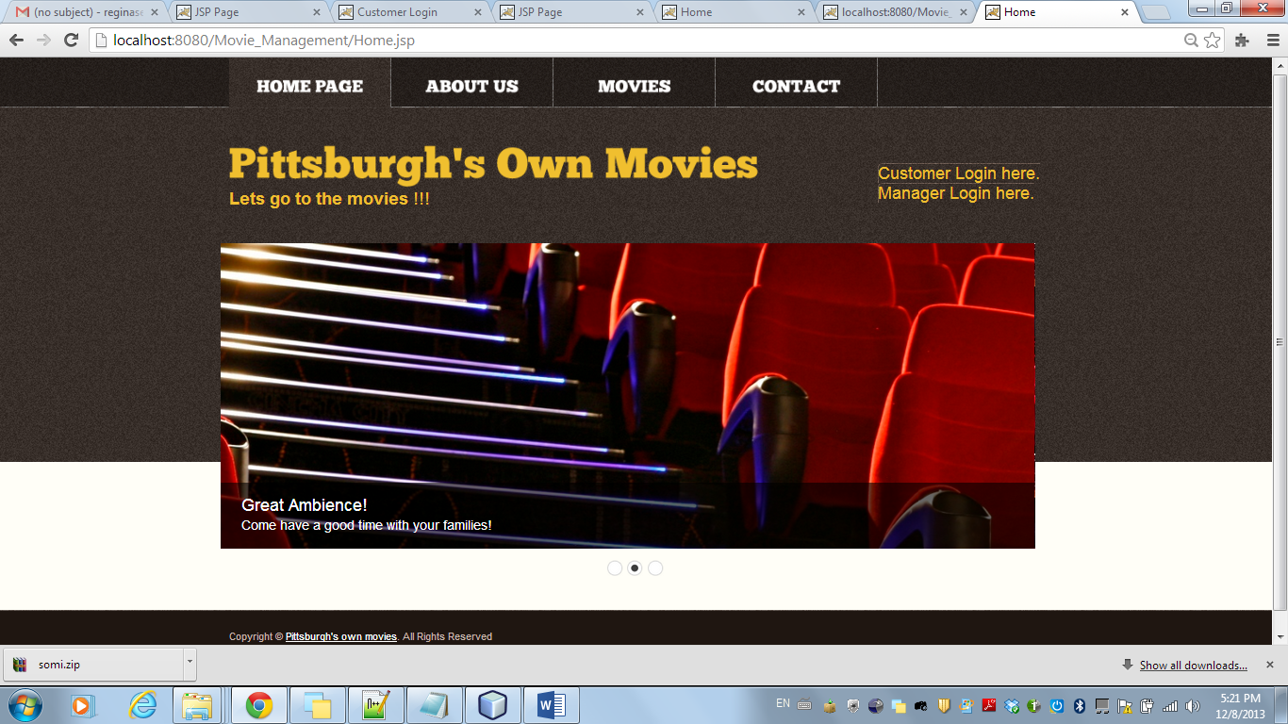

2. **Sign Up Page**: This page appears when the user clicks on the option ‘New User’ on the home page. The user will have to insert all the necessary details asked on this page to sign up. Here validation page has been corporated where in the user needs to fill in all the necessary details. If a certain field is left blank then the validation note pops up to the user. Once the sign up page is submitted the user is asked to log in with the credentials (user id and password) submitted on the sign up page after which he/she is directed to book ticket page where he/she can view the show timings and book the tickets. The page appears as below:

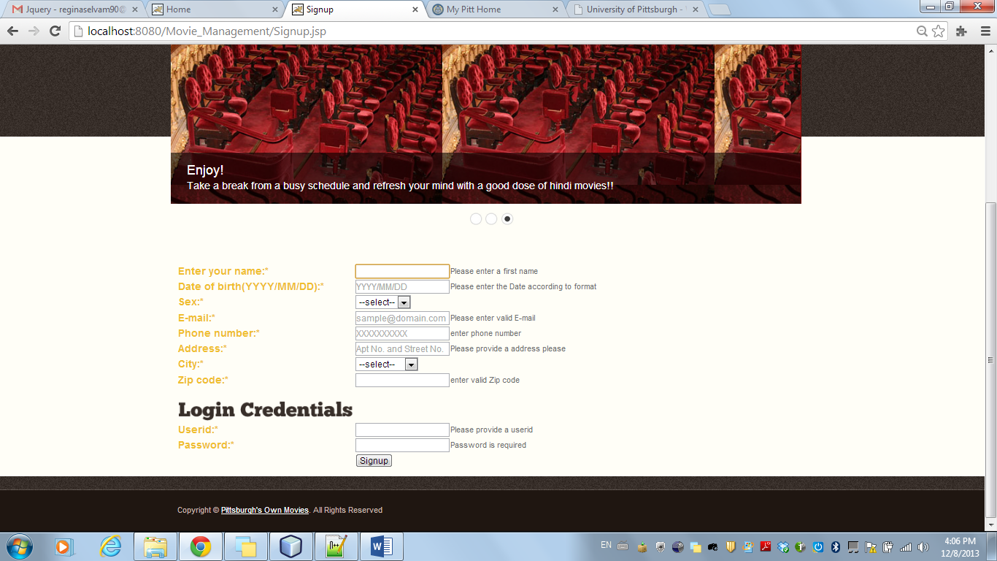

3.**About US**: The user can view the description about the theater on this page.

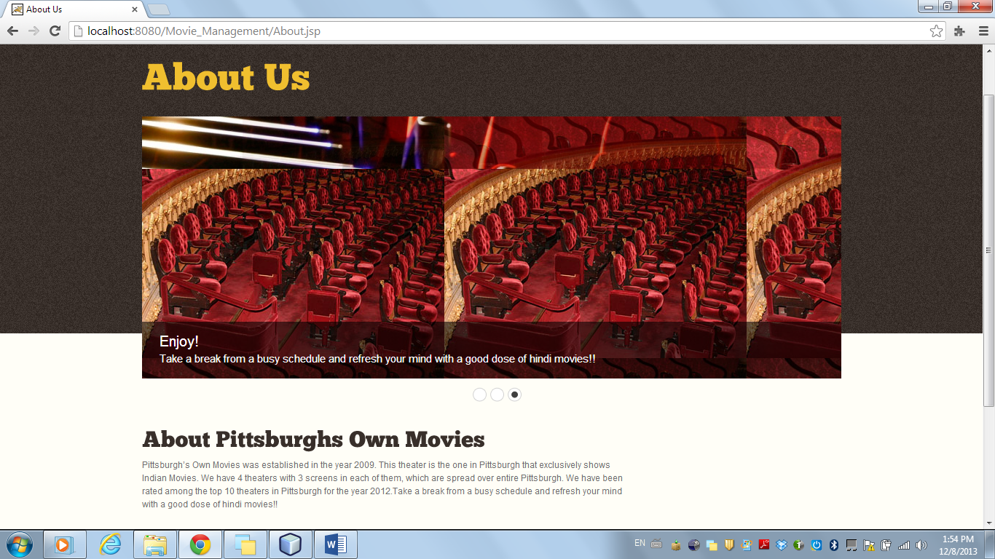

4.**Movies**: The user without logging in can view this tab/page, which holds data about all the released movies and the upcoming movies. It also hold trailers for each movie in order for the user to decide if he/she wants to watch the movie or not.

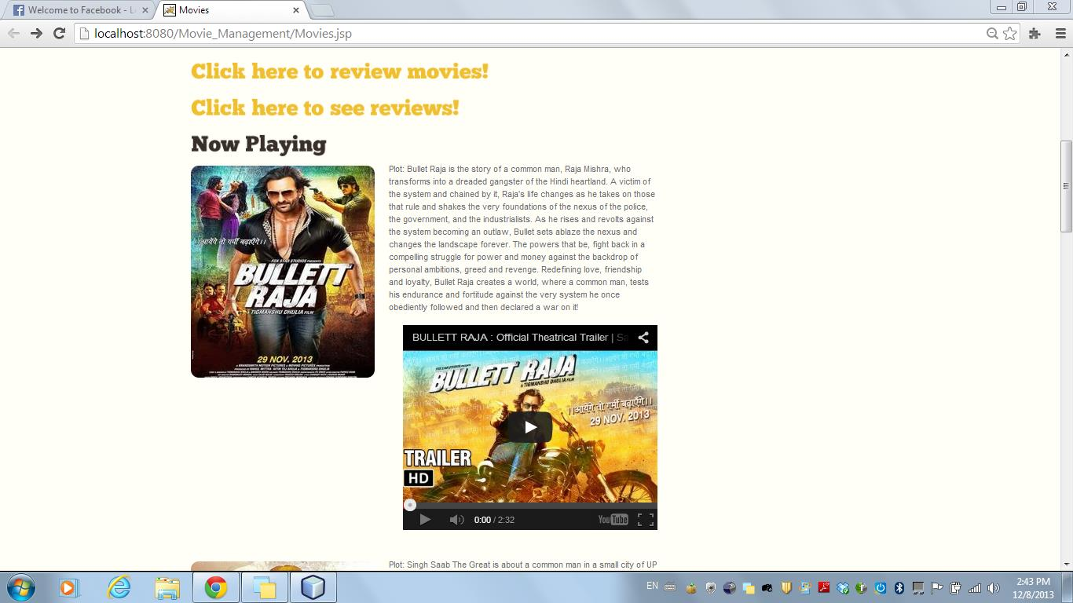

5.**Contact Us:** The user on this page can view details (timings, address, and phone number) for all four theaters located at South Side, Greenfield, Bloomfield and South Oakland.

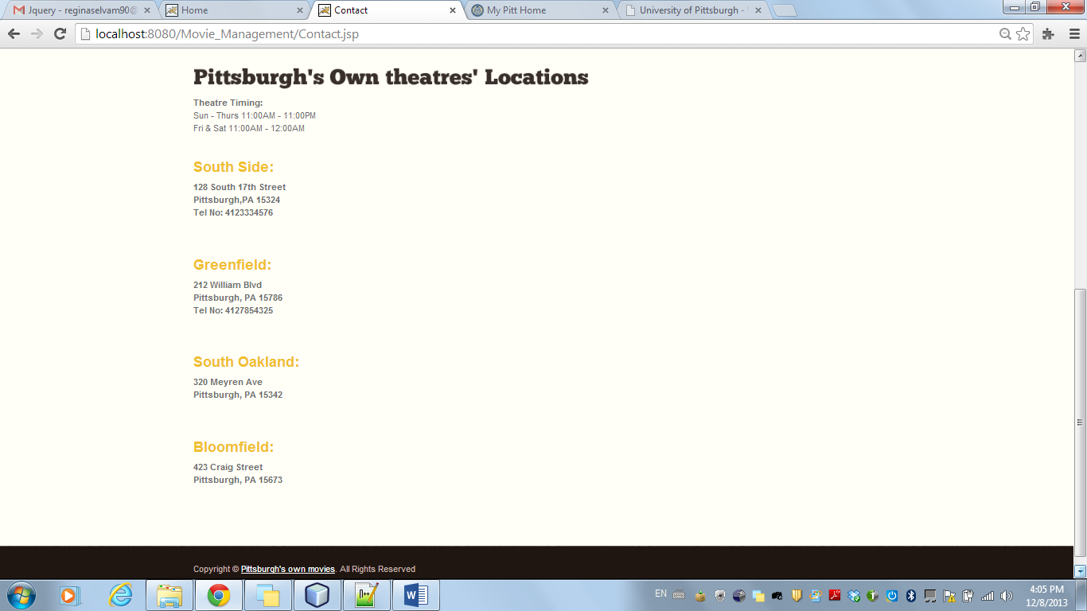

6. **Book Ticket**: Once the user logs in there are four tabs book ticket page is opened for the user to select the movie he/she wants to watch with its timings and location options. The user can select the Book ticket tab to view the show timings and book tickets for a show. Once the tickets are booked the user is directed to a generate ticket page where a ticket is generated for the show timing the user had booked.

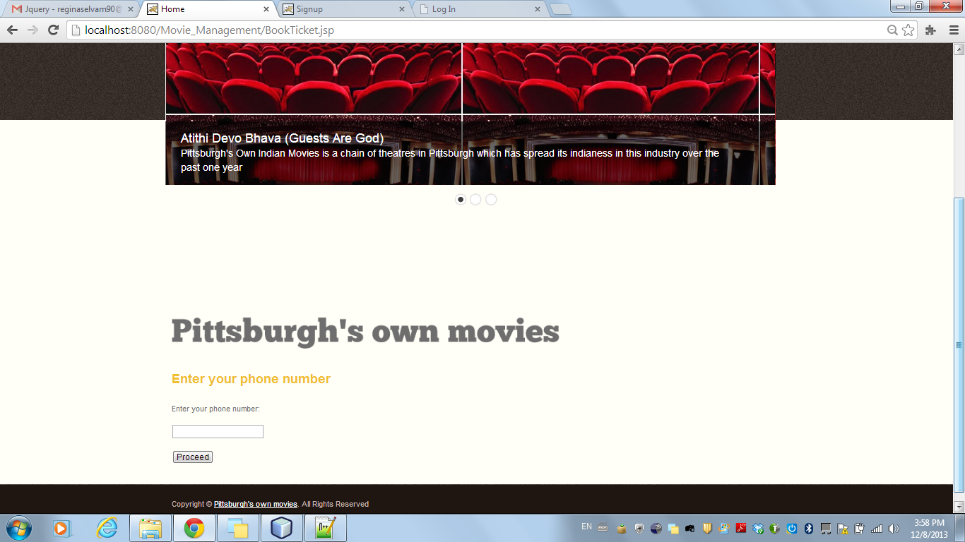

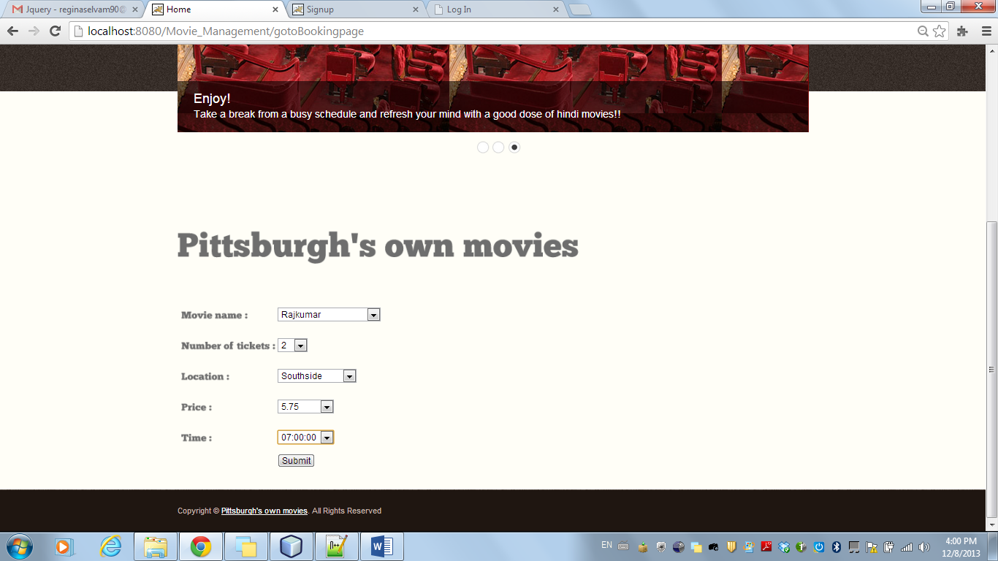

7.**Generate Ticket:** Once the user confirms the order of his ticket he will be directed to a page where the ticket will be generated with a confirmation. After which the user can logout and will be directed back to the Home page.

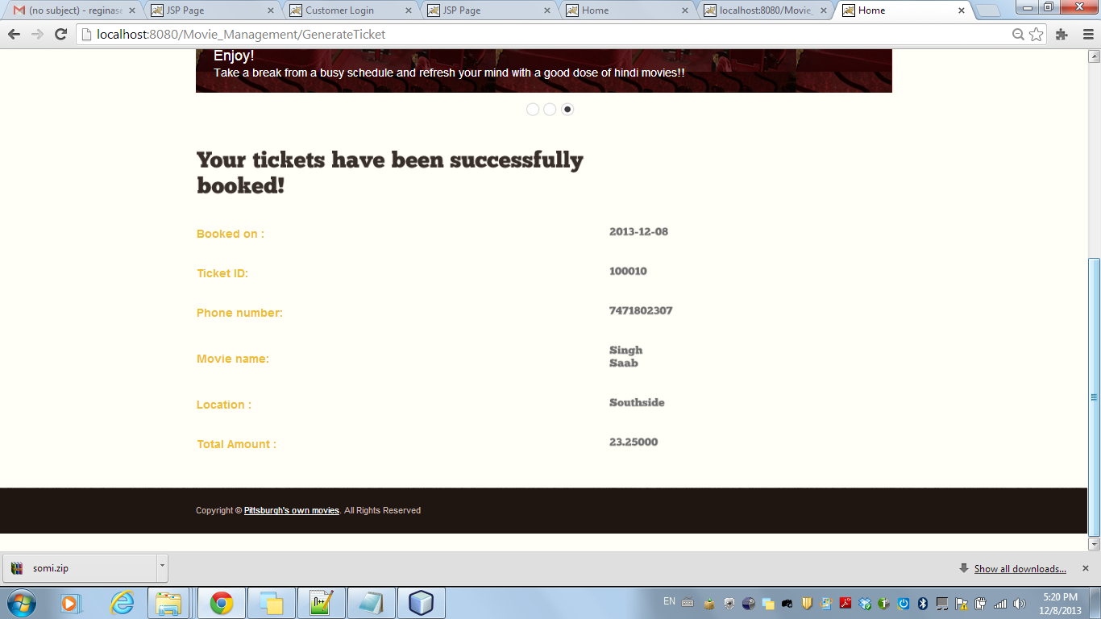

8.**Review Page:**

**Part 1: To review a movie**

This page allows the login user to rate a movie as per his choice and there’s a text box where the user can write about his/her views on the movie.

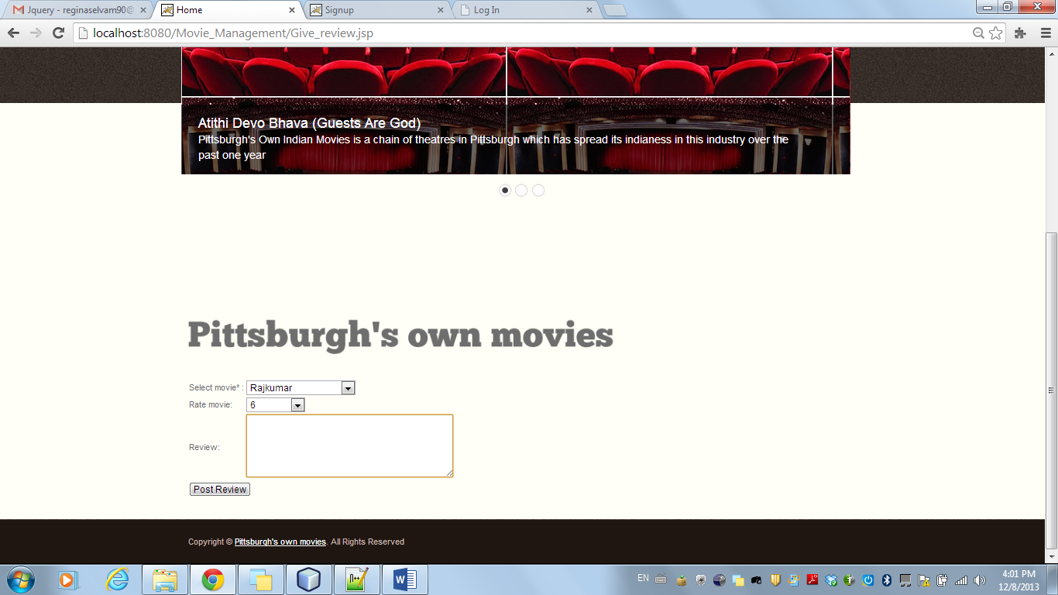

**Part2: To view the review**

Once the user submits the review for a movie of his choice, the reviewed movie post is uploaded/viewed here. This page displays all the movies reviewed y other users too.

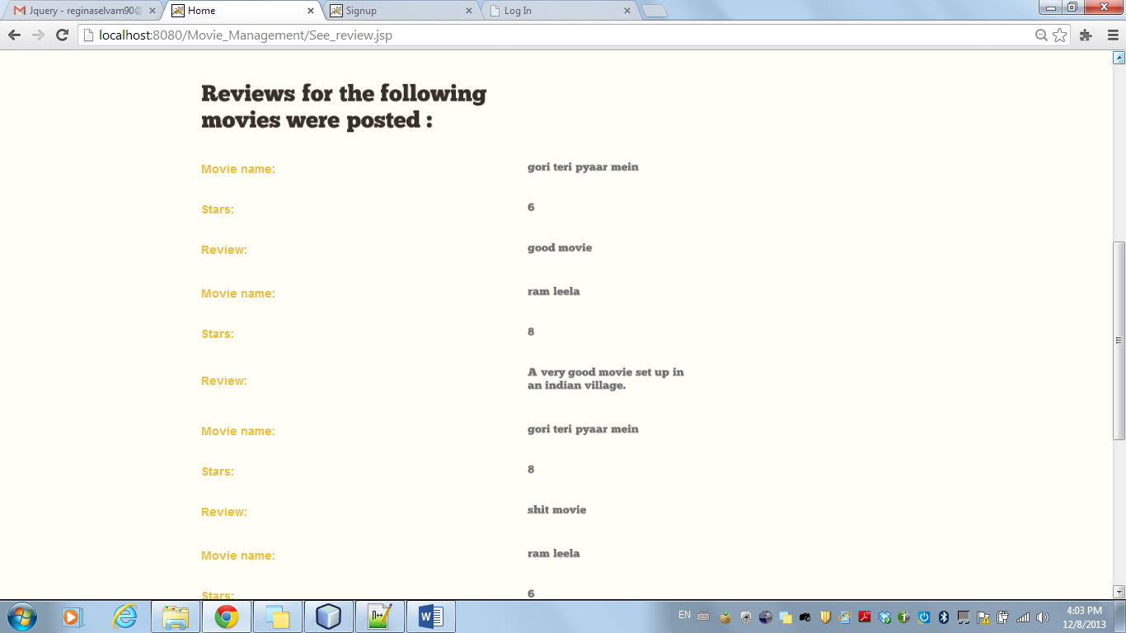

**Manger Login**: On the home page there’s a Manger Login option for the Manager to sign in in order to check the total sales.

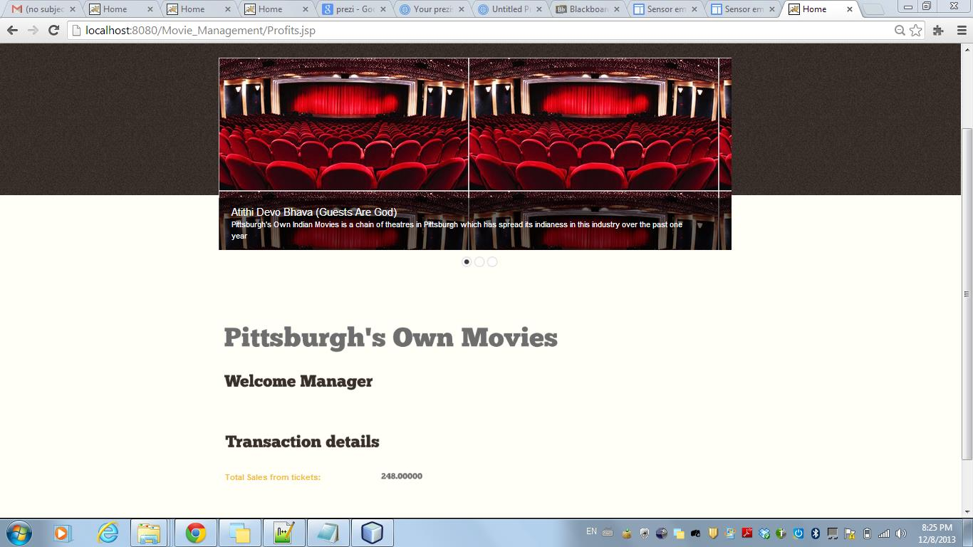

**Conclusion**

We aimed at creating an online website for a Pittsburgh customer to view show timings of a movie/movies, book tickets and also review the movie/movies. Also the manager can view the required total sales for a particular day.